mopa‘3-1 Milestone: Database Indexing and Authentication

CS340 Client/Server Development

Nicholle Caudy

3/18/2025

**Part 1: Importing and Indexing a Data Set**

1. Upload the Austin Animal Center (AAC) Outcomes data set into MongoDB by importing a CVS file using the appropriate MongoDB import tool. Use the database name “AAC” and collection name “animals.” Screenshot of both the import command and its execution.

1. Open mongo shell, create a simple index on the key “breed.”

Show an example query using this index.

Use the explain function to verify that the index will be used.

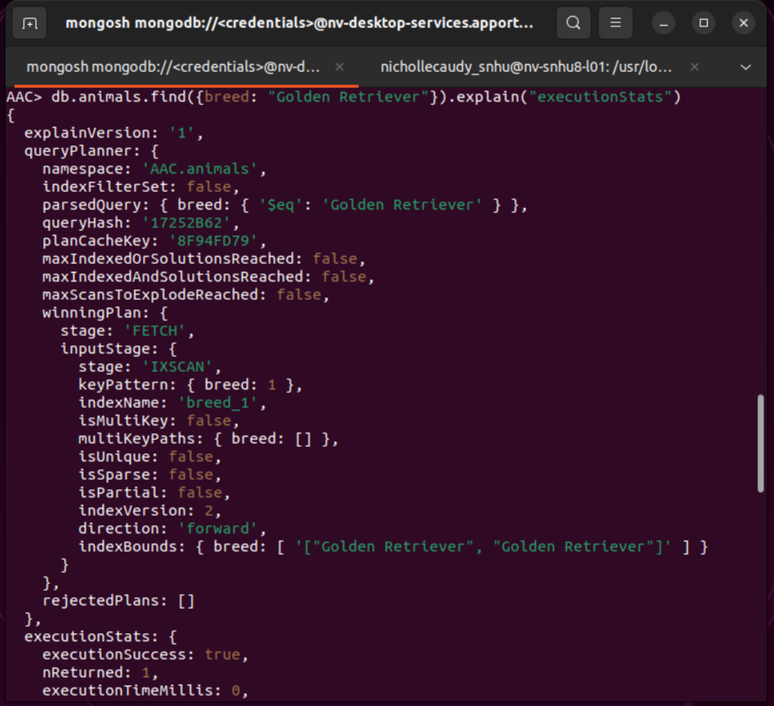

1. Create a compound index that will improve the performance of queries looking for breeds and have an “outcome_type” of “Transfer.” Show an example query using this compound index.

Use the explain function to confirm the index will be used.

**Part 2: User Authentication**

1. Create a new user account called “aacuser” for the database AAC in the mongo shell. Modify the commands so the account name is “aacuser.”

1. Take a screenshot of the login process to MongoDB using the mongo shell. Be sure you can access MongoDB and list the databases using both the admin and aacuser accounts. Use the db.runCommand({connectionStatus:1}) to verify that you have connected as a specific user.

